INTRO

Saratoga Title & Escrow, Inc. is truly a home grown business finding its strength in employees that have been part of the area community since youth. Opened as Saratoga Title Agency in 1987, the name was changed in 1998 to better reflect the line of full service title research, title insurance and settlement services provided by the company. We have offered title and settlement services to the area since inception and from our present location since 1999. Every business touts experience but at Saratoga Title experience is a given. Stability is the key in delivering real estate closings with efficiency and accuracy. Core staff members have been with us since the doors opened. As the business grew new employees joined our team and have been with us since. Everyone at Saratoga Title is dedicated to making your real estate settlement an educational and pleasant experience.

So let’s have some fun……….

**SID WORLEY—President/Owner**

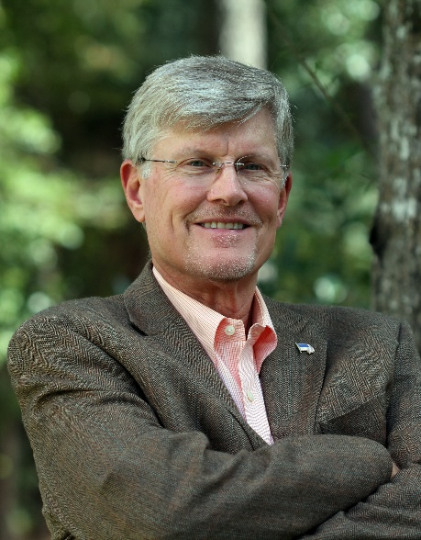Born and raised in Prince William County, Sid began developing a strong work ethic at age 10 by mowing neighbors’ lawns and delivering handbills. During high school and college, grocery store clerk, brickyard hack, tire salesman, tax researcher, a college professor’s assistant and a member of an 11 piece 1960’s soul band were added to his resume’. After college he worked for local area law firms, was a financial institution officer, land developer and managed a thoroughbred horse farm during the early years of building Saratoga Title & Escrow.

The devastating loss of his father at 14 caused Sid to gain a new respect for his hard working mother. “My father’s death brought light to the sacrifices that my mother made in order to provide me with opportunities that were available neither to her nor my Dad. The continued support of my father’s employer demonstrated the concept of business as a family. I think about that daily, and have done all that I can to make my business a family”.

Now retired to Pawleys Island, SC, Sid consults and interacts with the business on a daily basis. He welcomes contact with clients, agents and lenders at any time.

**DAVE BYRAN—Executive Vice President**

Coming……………

Lkjsdf;lkjwaerpo8iturvjnj posfe[p oiwaserf[poi a[spfoi asofiawfposid poasief spsodfif [spSDOfikf [psodif psoif [psokdf posikef [puief [pw9sief [pSODikf [adoif [psodidf [pSOif [pSODFi [pSODif [psoif [psoIidf [w09eirf =09wefi SIOPZDJfcv po8sdef [PSODJkfc ‘pSODkcjfv [S(u9df [s)(uif pSZODcjfv piosa8uyder [09wsefu [09waseuf spODcvj [s9euf 0w89euf ]90-ioiaserf[09wuef[‘sCVj;olisZdjzcvp[09wSEif]epsefi

AwesdO89U [AsoeiU [89EU 09UIEASDF [09EUI 8ERJHFCHVJHVCKJhzpisD[OI 890Ju[g89vu [99asf v00sef9i09999SDE9fi

**JUDY MULLINS—Vice President**

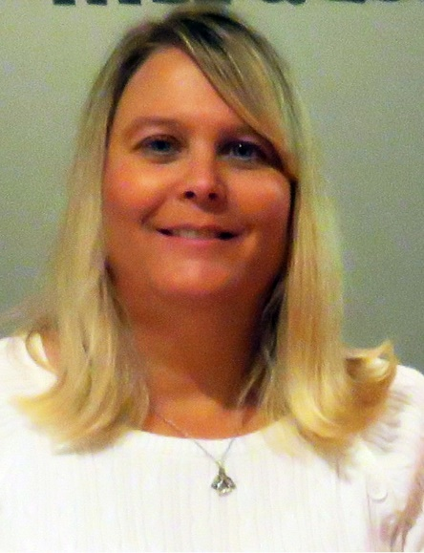If Saratoga Title ever sustained a mortar attack Judy would be the first to catch the incoming round. She is literally on the front line of most transactions that come to Saratoga Title. A work fanatic with only one speed…..**fast!** A native of Prince William County, Judy has worked and lived in the area all her life. 32 years in the working world, 30 of which have been in the financial, legal and real estate settlement sectors, Judy has always held herself to the highest ethical and efficient standards. If it’s not right and accurate, Judy will not do it.

Family is the center of Judy’s life. Her husband, Tim, and sons, T.J. and Tyler are in her heart and mind every day. In addition to family, she tends to the needs of Diesel, Jake and Maddie, their three dogs who she considers extended family. In her spare time (how does she have spare time?) Judy handles invoicing, estimates and all accounting for T&J Ceramic Tile, Inc., a tile and flooring installation company which she partners with her husband, Tim. AND……by the way, Tim does great work. It’s precise and neat. Just look at his truck, you could eat off the floor!

**MARY CATHERINE WORLEY—Corporate Secretary/Bookkeeper/Payroll/Accounting**

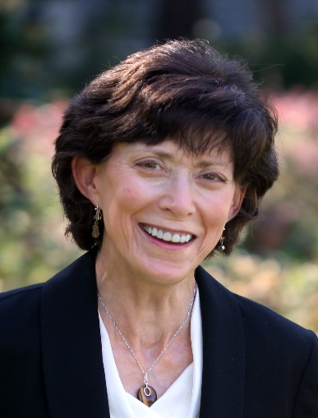“Stable” is the key word for Mary Catherine in more ways than one. Mary Catherine is the person that takes on a task, does it right and sticks to it until finished. This South Carolina native spent summers as a youth visiting relatives in the Fauquier area becoming involved in equine related disciplines, and going on to graduate from Virginia Tech. Local foxhunting and showing laid the groundwork for 13+ years as a thoroughbred race horse trainer. Initially splitting time between managing a local veterinary clinic and a racing stable, the racing stable eventually developed into a full time endeavor. Maryland, Delaware, Pennsylvania, West Virginia and Virginia provided racing venues for a successful string of thoroughbreds over the years, all the while keeping the corporate books and records of Saratoga Title since its move to Warrenton in 1998.

**DEAN HONEYCUTT—Settlement Officer**

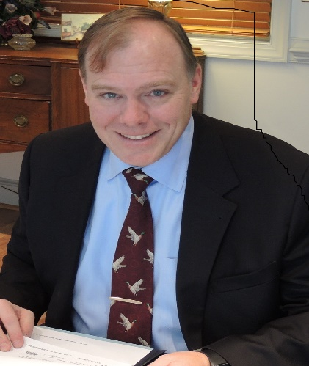Now here’s an interesting guy. Another local who grew up in Fauquier County. Well rooted in the business development and technology, Dean came to Saratoga Title with an excellent foundation from the real estate title research sector. Reserved in his own way, Dean rarely mentions his talents as an accomplished bass guitar player, having recorded, toured and played with various bluegrass to new age instrumental bands. While dedicating 8 years as an instructor, Dean authored two methodology books utilized in the development of student lessons.

Spare time finds Dean building and flying large radio controlled helicopters with which he produces aerial mapping, photos and videos. As a man of tall statue, his Harley Street Glide is an appropriate fit for frequent trips into the Virginia countryside. Quite a contrast in size, is Deans sidekick, Peanut, a miniature pinscher.

**MARSHA GRAVES—Post Closing**

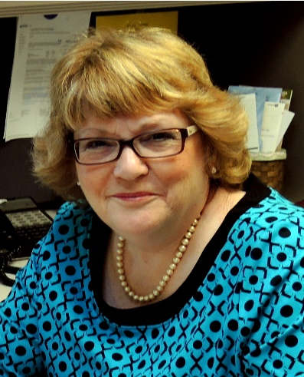Marsha’s our “Mom”. Holidays, cookies, cakes, scrap books, Christmas decorations, and little frilly things are her specialty. Credentials as an Army brat, an Army/Air Force employee and an Army wife, probably changes her status from “Mom” to “General”. But this General never barks orders she’s more of a soft sail in the hard wind of a busy office. Experience in property management and the travel industry has helped her capture 5 stars in customer service.

As our post-closer, organizational skills pertaining to after closing details is a must. Timed delivery demands and maximum accuracy make her job difficult, but a great attitude contributes to getting the job done correctly and on time. Marsha possesses a unique ability to find some mental quiet zone in which to move forward. Just be careful, in that haven of solitude dwells a mischievous lady. Various shapes and sizes of confetti products may rain down upon co-employees with no warning.

**HEATHER PLEMMONS—Administrative Assistant**

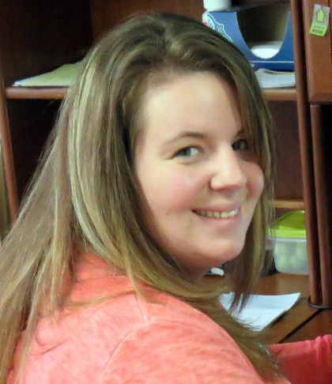New to Saratoga Title & Escrow, Inc., Heather is proving to be a welcome addition. A task has yet to be presented that she hasn’t been willing to tackle. Having had a variety of jobs, again demonstrates an eagerness to work to do what has to be done to support a young family. From having worked in banks, a flower shop, an auto repair business, to serving ice cream, Heather considers all to have been amazing jobs while working with great people.

Another who cherishes family, Heather looks upon her mom as her “biggest cheerleader”. She considers her mom’s advice “Always tell your loved ones you love them when you leave” as a life lesson she applies every day.

**DANIELLE HOLDEN—Title Production**

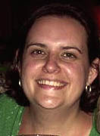Once with Saratoga Title & Escrow, Inc. full time, Danielle has broadened her horizon with employment closer to home but with the miracles of technology, remains connected electronically and as a continuing part of the Saratoga family. A Fauquier County resident from a very early age and Fauquier High School graduate, Danielle remains well based locally maintaining many contacts and friends.

At home the personalities of Franklin and Penelope, her two adopted cats, sometimes present a conflict of interests but she wouldn’t trade them for the world. One of the small Hawaiian islands might be tempting but the offer has yet to come.

We’re excited to have Danielle back as part of our team. Having been with us for 13 years her experience as a licensed title insurance agent production expert make her a valuable asset to Saratoga Title